1. Find the vertex of the parabola: x2 + 6x – 3y + 21 = 0.

CW: HPC Benchmark 4 Review 1

Name:

Date: PD:

1. What is the directrix for 
2. Simplify: 

A

B

40°

b

50

C

60°

70

1. Answer true or false for each equation given the following triangle.
2. 
3. 
4. 
5. 
6. 
7. Which type of conic is represented by each equation.

a. 

b. 

c. 

d. 

1. Simplify 
2. A Donk wants to measure the width of a hill near his bike trail. From point A, he measures the distance to each end of the hill and the angle between the two sides. What is the approximate width of the hill?

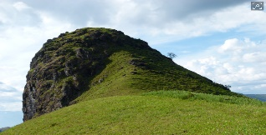

A

200 ft

150 ft

60°

1. Solve the system 
2. Find all the solutions for 
3. Find the exact value for 
4. Use sigma notation to write 
5. Find the common difference for the arithmetic sequence defined by an = 5 + 3n
6. Find the sum for the geometric series 
7. Simplify: 
8. Find all solutions for 2sin(3t) = 1 on [0, 2π)
9. Find all solutions in the interval [0, 2π) for cosx + sin2x = 1
10. Find all solutions in the interval [0, 2π) for 
11. Write the standard form of the equation of the circle with center (-3, 4) and radius 6.
12. Find the vertex of the parabola x2 – 6x – 4y + 29 = 0
13. 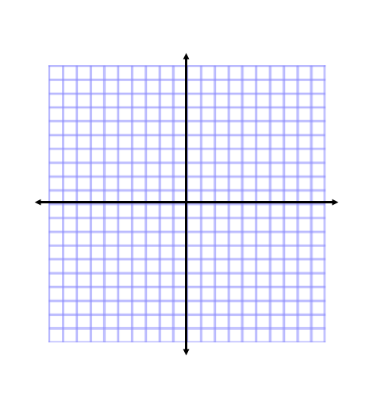Graph 



1. Graph 