HW: Cumulative Review Packet

1. Given the polynomial function: 
   1. How many rational zeros does the function have? _______
   2. Use Descartes Rule of Signs to determine how many positive zeros are possible? _____________
   3. Use Descartes Rule of Signs to determine how many negative zeros are possible? _____________

f(-x) =

* 1. Use the Rational Zeros Theorem to determine the list of all possible real zeros?

_____________________________

* 1. Is the leading coefficient positive or negative? __________
  2. What is the right-hand behavior of the function? ________________
  3. What is the left-hand behavior of the function? ________________
  4. What is the y-intercept? _________
  5. Use the list of possible real zeros and synthetic division to factor the function completely. Write the polynomial as a product of its linear factors.

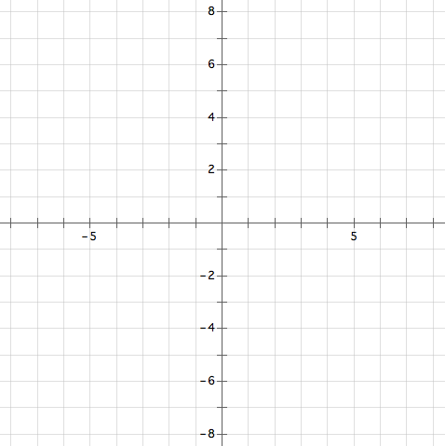

f(x) =

* 1. What are the zeros of the function, each zeros multiplicity,

and will the graph cross the x-axis or not at the zero?

Zero: Multiplicity: Cross: y / n

Zero: Multiplicity: Cross: y / n

h) Sketch a rough graph including end behavior,

all real zeros, and the y-intercept.

1. Given the function 
   1. Find all the rational zeros of the function. Zeros:__________ , __________ , __________
   2. Write the polynomial as a product of its factors. f(x) = ( )( )
2. Given the function f(x) = x3 – 8x + 8
   1. find all the real zeros: ___________ , ___________ , ___________

Use the quadratic formula if necessary: 

4) f(x) = -2x2 – 8x – 5

A. Write the function in h – k form (standard form)

B. Sketch a graph of the function.

5. Given the functions f(x) = $\sqrt{x}$, g(x) = $\sqrt{x+2}+1$

A. State the domain and range of f(x) B. Sate the domain and range of g(x)

6. Use the graph of y = f(x) to sketch the graph of y = f(x – 4) + 3



y = f(x – 4) + 3

y = f(x)