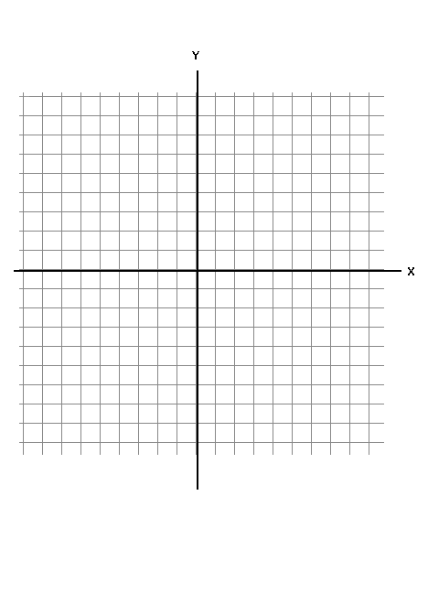
Leading Coefficient Test / End Behavior / Multiplicity
Name:
Date: PD:
OPEN NOTES QUIZ (20 Product Points)

zeros | Even or Odd multiplicity | Crosses x-axis (yes/no)

Bonus:
Given the function f(x) = x² – 3x + 1 can you verify f(x) = 3 at some point on the interval (-1, 2). Explain your reasoning.
Use the given function to answer the following questions and then give a quick sketch of the function
f(x) = x⁴ – x³ – 6x²

a)

b) y-intercept: _________

c) End behavior (circle one for each side):

Right side: Rises right / Falls right

Left side: Rises left / Falls left

d) Give a test point between each x – intercept.

( , )

( , )

e) Use the information you determined above to sketch the graph of f(x) on the graph provided.

