1. For the triangle shown, find the possible lengths of side c.

C

A

B

37°

50

40

CW: **SENIOR** HPC Benchmark 4

Name:

Date: PD:

1. Find the area of the triangle with sides of length 10, 11, 12.
2. Simplify: 

A

B

40°

b

50

C

60°

70

1. Answer true or false for each equation given the following triangle.
2. 
3. 
4. 
5. 
6. 
7. Given ΔABC, let AB = 11, BC = 8 and AC = 5, find m∠C.
8. Simplify 
9. A Donk wants to measure the width of a hill near his bike trail. From point A, he measures the distance to each end of the hill and the angle between the two sides. What is the approximate width of the hill?

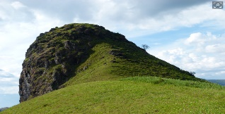

A

200 ft

150 ft

60°

1. Solve the system 
2. Find all the solutions for 
3. Find the exact value for 
4. Use sigma notation to write 
5. Find the common difference for the arithmetic sequence defined by an = 5 + 3n
6. Find the sum for the geometric series 
7. Verify: 
8. Find all solutions for 2sin(3t) = 1 on [0, 2π)
9. Find all solutions in the interval [0, 2π) for cosx + sin2x = 0
10. Find all solutions in the interval [0, 2π) for 

A

1. Find the length of AB

25cm

63o

56o

C

B